Name:
Institution affiliation:
Course:
Date:

Concept and reasoning checks 1.1
- How were the first microbes discovered?
Were discovered, during a scientific research, the microorganisms were observed as early as 1680s during an observation using microscopes where they discovered bacteria and structures of mold.
- If you were alive in Leeuwenhoek’s time, how would you explain the origin for the animalcules he saw with his simple microscope?
In the early years, Leeuwenhoek visited London where he observed water closely and that’s when he was surprised to see tiny organisms. This is when he performed experiments and was able to confirm this discovery. He as well laid foundations on plants and animal reproduction where he discovered blood cells and microscopic nematodes and also sperms which he considered one of the most important discoveries of his career. Hence the animalcules found were tiny microscopic unicellular organisms which were discovered in decaying or even inanimate matter.
- Evaluate the role of experimentation as an important skill to the eventual rejection of spontaneous generation as an origin of animalcules (and microbes).
Experimentation done by an Italian naturist tested that flies must have access to meat for the maggots to develop on the meat. This proved that spontaneous generation would not hold true for larger organism.
Concept and Reasoning Checks 1.2
- How do the procedure of variolation and vaccination contradict the concept of miasmas?
Vaccination entails administering vaccines that activate the immune system and protecting against a specific virus or bacteria. The procedure of variolation and treatment had a lot of risks; the method could lead to the death of the patient and the spreading of the airborne disease thus causing an epidemic
- How the work of Semmelweis and snow challenge the widely held idea of miasma as the cause of infectious disease.
Epidemiology is applied for contagious diseases, and it is an inquiry example. of scientist for discovering the cause, source, and mode of transmission of any disease. Semmelweis was surprised used to know the number of women that were dying. As a result of puerperal fever that follows labor Semmelweis came up with the conclusion that fictions were much more prevalent twenty times, as well as extremely deadly inside the ward that is handled through the medical students rather than the adjacent ward and operating using midwifery students.

Concept and reasoning check 1.3
a. How did Pasteur’s studies of wine fermentation and souring suggest to him that germs might cause harm to human infectious disease?
Pasteur’s suggested that each type of fermentation is caused by a specific kind of microbe and that bacteria and protozoa caused fermentation and sour in wines.
b. Assess Lister’s antisepsis procedures and Pasteur’s studies of Pebrine to supporting the germ theory.
Lister suggested on modern infection control to prevent infection during surgery while Pauster’s studies suggested that worms became ill when they nested in the bedding of those suffering from the disease.
c. Explain why Koch’s postulates were critical to validating the germ theory.
In this case the bacteria must be isolated from the host and grown in pure culture. When a pure culture of the bacteria is inoculated the specific disease must be reproduced.
d. How did the development of pure cultures advance the germ theory?
Pure cultures allow the pure isolation of a microbe which is vital in how individual microbe may contribute to germ mutation.
Concept and reasoning checks 1.4
a. Describe how viruses were discovered as disease causing agents.
Viruses replicate inside living cells of an organism since they are infectious and microscopic hence causing diseases.
b. What significant discoveries added the fungi and protozoa to the growing list of microbes?
The discovery that both microorganisms collectively inhabit in aquatic environments.
c. Judge the significance of pioneering studies carried out by Winogradsky and Beijerinck.
The studies found that yellow fever was actually a virus and that tobacco mosaic disease was actually due to a liquid that was contagious.
Concepts and reasoning checks 1.5
a. What roles microorganisms play in the understanding general principles of molecular biology?
Microorganisms represent a molecular diversity in nature by maintaining dynamic relationships among them with superior organisms.
b. Distinguish between prokaryotic and eukaryotic cells.
Prokaryotic cells don’t have a nucleus and have a free floating material while eukaryotic cells have a distinct nucleus containing the cell’s genetic material.
Prokaryotic cells do not have a membrane bound nucleus while eukaryotic cells have.
c. Assess the importance of Fleming’s discovery and Florey and chain’s production of penicillin.
The discovery of penicillin could treat infections that were fatal like bacterial meningitis and pneumococcal bacteria among others.
Concepts and reasoning checks 1.6
a. Briefly discuss four examples of the challenges facing microbiology today.
1. Maintaining compliance levels- managers should arrange for compliance audits to be conducted to demonstrate an absence of regulatory risks in these areas (Greninger, 2018).
2. Promoting advanced aseptic processing technologies- technology changes will improve sterility assurance especially if they significantly reduce interventions and product exposure.
3. Increasing microbial testing productivity, flexibility and cost effectiveness- look for opportunities to improve laboratory efficiencies for routine testing and outsource highly technical microbial tests (Greninger, 2018).
4. Implementing rapid microbial methods- it is possible to achieve significant improvement in product release times through better scheduling resource allocation so that the improvements can be considered low-hanging compared to rapid microbial methods.
Multiple choice
- Who was the frst person to see bacterial cell with the microscope? {C}
- A
- C
- D
- C
- A
- B
- B
- A
- A
- A
- D
- D
- A
- A
- C
Concept and Reasoning Checks 2.1
- Explain how atomic Numbers Differs From Mass Number
The main difference between atomic number and the Mass number is that nuclear number reviles the number of protons present un a particular atom whereas mass number reviles the total number of protons and neutrons present In an atom
- Describe how an isotope Differs from an ion
An ion is an Atom containing a net electric charge due to the gain or loss of one or more electrons. An Isotope is every two or more forms of the same elements containing the same amount of protons but different neutrons in the nuclei and therefore differs in relative atomic mass, however not in chemical properties.

Chapter 2.2
- Construct a diagram to show how the salt calcium chloride (CaCl2) is formed.
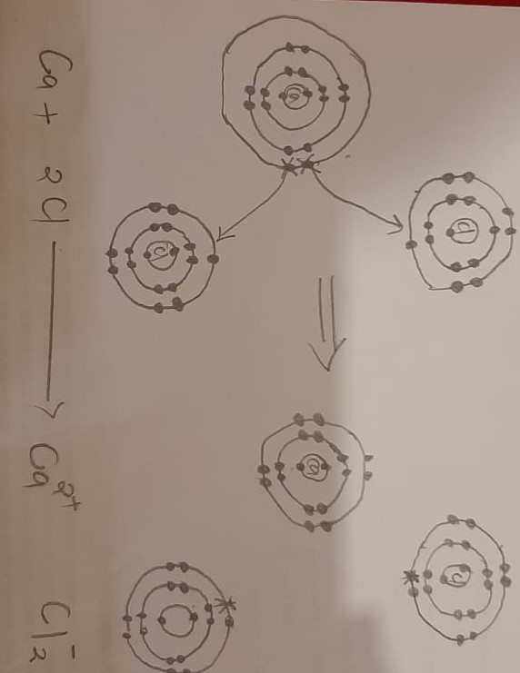
- Why do atoms share pairs of electrons
This is to gain more stability
- Construct diagram to show how hydrogen bonding occurs in a molecule of liquid ammonia (NH3)
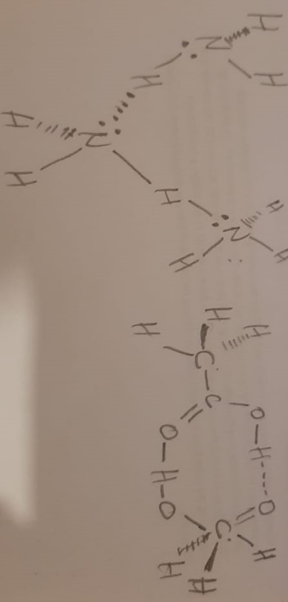
- Compare and contrast dehydration and hydrolysis reactions.
In dehydration reactions, a water molecule is formed as a result of generating covalent bond between two monomeric components in a larger polymer while in hydrolysis reaction a water molecule is formed as a result of breaking covalent bond holding together two components of a polymer.
In dehydration, molecules generally require energy while hydrolysis molecules break down as a result of losing energy.
2.3
a. Explain the difference between a solution, solvent and a solute.
A solution is a mixture of two substances mixed together evenly, a solvent is the dissolving liquid while a solute is the substance to be dissolved.
b. What are the properties of acids and bases?
Acids taste sour, react with metals, react with carbonates and turn blue litmus paper red while a base tastes bitter, feel slippery, do not react with carbonates and turns red litmus paper blue.
c. If the pH does drop in a cell, what does that tell you about the buffer system?
If the pH drops in a cell that means the equilibrium is not balanced in the solution.
- Explain how atomic number differs from the mass number.
Atomic number of protons in an element while mass number is the number of neutrons and protons in an element.
- Describe how an isotope differs from an ion.
An isotope are atoms that have the same numbers of protons but different numbers of neutrons while an ion is an atom that has gained or lost electrons to contain less protons.
2.4
a. What is common to all functional groups except the carbonyl group?
All functional groups have a similar fashion and similar reactions
- Discuss how stable monosaccharide are assembled into the energy storage and structural polymers. Give examples.
Monosaccharide’s are carbohydrates and form a basic macromolecules of life. They include: glucose and fructose.
- Explain why lipids are not considered polymers whereas polysaccharides, polynucleotides and polypeptides are considered polymers.
Lipids are not polymers because they consist of smaller units of glycerol and fatty acids while polynucleotides consist of repeating sequence of certain amino acids (Olatunji, 2016).
- How does the structure of DNA differ from that of RNA?
DNA has four nitrogen bases adenine, thymine, cytosine and guanine while RNA has thymine. DNA has a double-stranded while RNA is single stranded (Roundtree, et al 2017).
- Why does a denatured protein no longer have biological activity?
A denatured protein contains secondary and tertiary structures altered but the peptide bonds of the amino acids are left intact (Liu, et al 2015). Hence the protein can no longer perform its function once it has been denatured.
Concept and Reasoning Checks: 3.1
- How would you describe Homeostasis in your own words?
It is the ability to maintain a stable internal state that persists regardless of the changes in the outside world.
- Universal structures and process that all cells possess as a living organism
Plasma membrane
Cytoplasm
Ribosome's
DNA
- The organelles found in most eukaryotic cells
Mitochondria, endoplasmic reticulum, chloroplasts, lysosomes, and the Golgi apparatus.
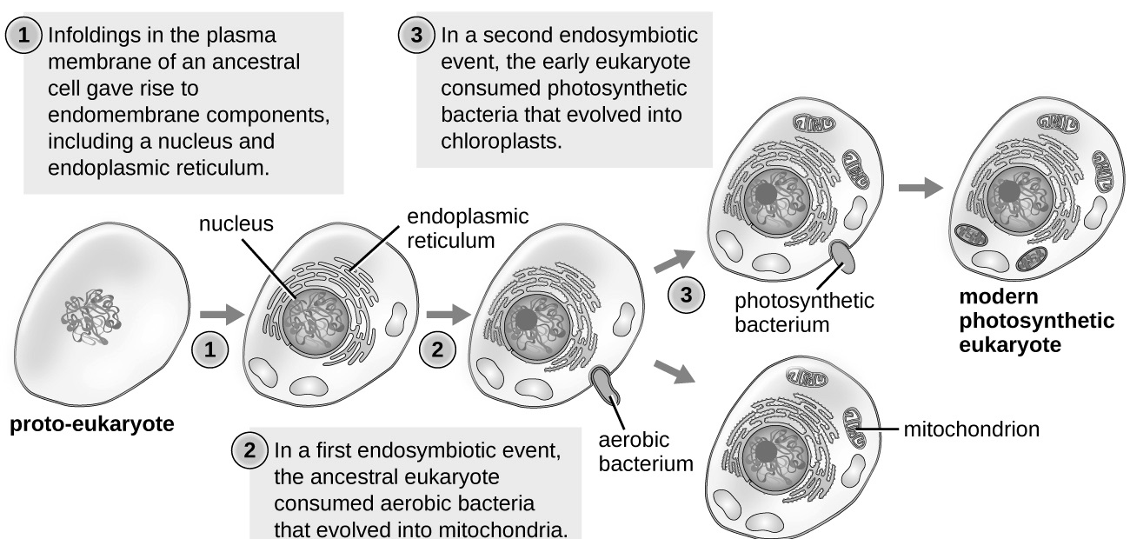
- A diagram illustrating the endosymbiont theory

Concept and Reasoning Checks: 3.2
- What four events changed the cataloguing of microorganism by shared characteristics
1.a Sweden scientist by the name Carous Linnaeus made the first attempt that placed organism into groups of two name Animalia and Vegetarian
2. Ernst Haeckel made the second attempt at a Germany scientist. He put the third group that he considered to consist of microbes and referred to it as Protista.
3. In 1959, a few years later, Rober H Whittaker placed the fourth group that was referred to as Fungi.
4. Herbert in 1956, set a fifth group that was seen to as Monera that was divided into two subgroups later referred to as Bacteria Arch bacteria by Carl Whose
- With regards to the three domains, it has been said that Woese ``listed a whole submerged continent out of the ocean ''What is the submerged continent ''and why is the term ``lifted '' used?
In the 1970’s Woes conducted living organism analysis based on the coding of their RNA. From his findings, he made a discovery of archaebacteria and a third taxonomic; domain. The archaebacteria live in environments that are extreme among them are the hydrothermal vents deep in the sea.
The domain has been revealed to be a significant ancestor (along, with eukaryotes and bacteria )where all the living organism descended. Archea were from the bacteria to a domain of its own.
- Which of the following is a correctly written scientific name for the bacteria that cause anthrax
Bacillus anthracis

- Why are numerous tests needed to identify a specific bacteria species?
A single characteristic, regardless of its importance, is not a sufficient basis to identify or classify an organism, to determine accurately a large and diverse strain sample needs to be tested to accurately determine the biochemical characteristics used for distinguishing a particular species.
Concept and Reasoning Checks: 3.3
- If a bacteria cell is 0.75μm in length, what is the length in nanometers
A bacterium cell I = 1000 nanometer
0.7 μm =?
0.75 x 1000 = 750-nanometer
- why is resolution more important than magnification
The word magnification itself explains that it magnifies the image. In some cases, there is no possibility of seeing the original object, which is small in size. The resolution, on the other hand, means to resolve .the term is closely related to the extent of separation of two objects that are closely attached; resolution helps in separately distinguishing two close objects. If the object does not contain proper resolution, you cant see the object with the magnification of 1000X properly.
- Explain the difference between cationic dye and anionic dye in terms of cell staining.
The bacteria cells are bind by Cationic dyes, which can be observed easily against the bright background. The cells repel Anionic Dyes, and therefore, they are illuminated against the stained background.
- Which techniques for improving contrast do not result in killing the cell?
Staining
It is a technique used for enhancement of contrast in samples .basically at Microscopic level,
- What type of electron microscope would be used to examine the surface structure of a bacteria cell?
(TEM) The transmission electron Microscope is u8sed for the examination of thin slices or sections of tissues or cells. The (SEM ) Scanning electron, on the other hand, has a tremendous depth of field that can be used for the examination of the surface structure of the specimen .this technique is used to study the surface site of photosynthesis that are found in photosynthesis algae or plant cells.

Multiple choices
- These positively charged particles are found in the atomic nucleus {A}
- A
- C
- D
- A
- A
- C
- C
- C
- D
- A
- A
- B
- A
- A

Step A: Review of the fact and terms
- What is the term that describes the ability of the organism to maintain a stable internal state?
B. Homeostasis
- Which on the following is an organizational pattern common to all organisms?
D. Endomembrane system
- Which of the .following is not found in Bacterial Cells?
C. Mitochondria
- Who is considered the father of Modern Taxonomy?
D. Linnaeus
- Was first to catalogue organism into one of three domains
B. Ribosomal RNA Genes
- Several classes of the body would be classified into one
C. Phylum
- An important automated method is used in the rapid identification of a pathogen.
D. Biochemical Testy
- Most bacterial cells are measured using what metric system of length?
B. Micrometres
- Before bacterial cells are stained and observed with the light microscope, they must be what?
All the Above (A-C) are correct
- . If you wanted to study the surface of a bacterial cell, you would use what?
C. Scanning Electric microscope

References
Roundtree, I. A., Evans, M. E., Pan, T., & He, C. (2017). Dynamic RNA modifications in gene
expression regulation. Cell, 169(7), 1187-1200.
Liu, E. J., Sinclair, A., Keefe, A. J., Nannenga, B. L., Coyle, B. L., Baneyx, F., & Jiang, S.
(2015). EKylation: addition of an alternating-charge peptide stabilizes
proteins. Biomacromolecules, 16(10), 3357-3361.
Greninger, A. L. (2018). The challenge of diagnostic metagenomics. Expert review of molecular
diagnostics, 18(7), 605-615.
Olatunji, O. (2016). Classification of natural polymers. In Natural Polymers (pp. 1-17). Springer,
Cham.
Hu, X., Mu, H., Zhang, X., Wang, Z., Tan, T., & Sun, J. (2019). Meta-SR: A magnification-
arbitrary network for super-resolution. In Proceedings of the IEEE Conference on Computer Vision and Pattern Recognition (pp. 1575-1584).
Chen, L., Chen, K., & Zhu, S. (2018). Transition-metal-catalyzed intramolecular nucleophilic
addition of carbonyl groups to alkynes. Chem, 4(6), 1208-1262.
Herzig, S., & Shaw, R. J. (2018). AMPK: guardian of metabolism and mitochondrial
homeostasis. Nature reviews Molecular cell biology, 19(2), 121.
Żur, J., Wojcieszyńska, D., & Guzik, U. (2016). Metabolic responses of bacterial cells
immobilization. Molecules, 21(7), 958.
Pu, Y., Zhao, Z., Li, Y., Zou, J., Ma, Q., Zhao, Y., ... & Ge, H. (2016). Enhanced efflux activity
facilitates drug tolerance in dormant bacterial cells. Molecular cell, 62(2), 284-294.

